**Jawaban Tugas Personal ke-2**

**Minggu 7**

Nama: Ardiansyah Halim Putra  
Binusian ID: 2702494382

1. Tabel transisi

|  | 0 | 1 |
| --- | --- | --- |
| S0 | S3 | S1 |
| S1 | S2 | S1 |
| S2 * | S2 | S4 |
| S3 * | S4 | S2 |
| S4 | S0 | S3 |

* 10000111 diterima, karena pada urutan S0 -> S1 -> S2 -> S2 -> S2 -> S2 -> S4 -> S3 -> S2, S2 merupakan state menerima.
* 01110000 ditolak, karena pada urutan S0 -> S3 -> S2 -> S4 -> S3 -> S4 -> S0 -> S3 -> S4, S4 merupakan state menolak.
* 01010101 ditolak, karena pada urutan S0 -> S3 -> S2 -> S2 -> S4 -> S0 -> S1 -> S2 -> S4, S4 merupakan state menolak.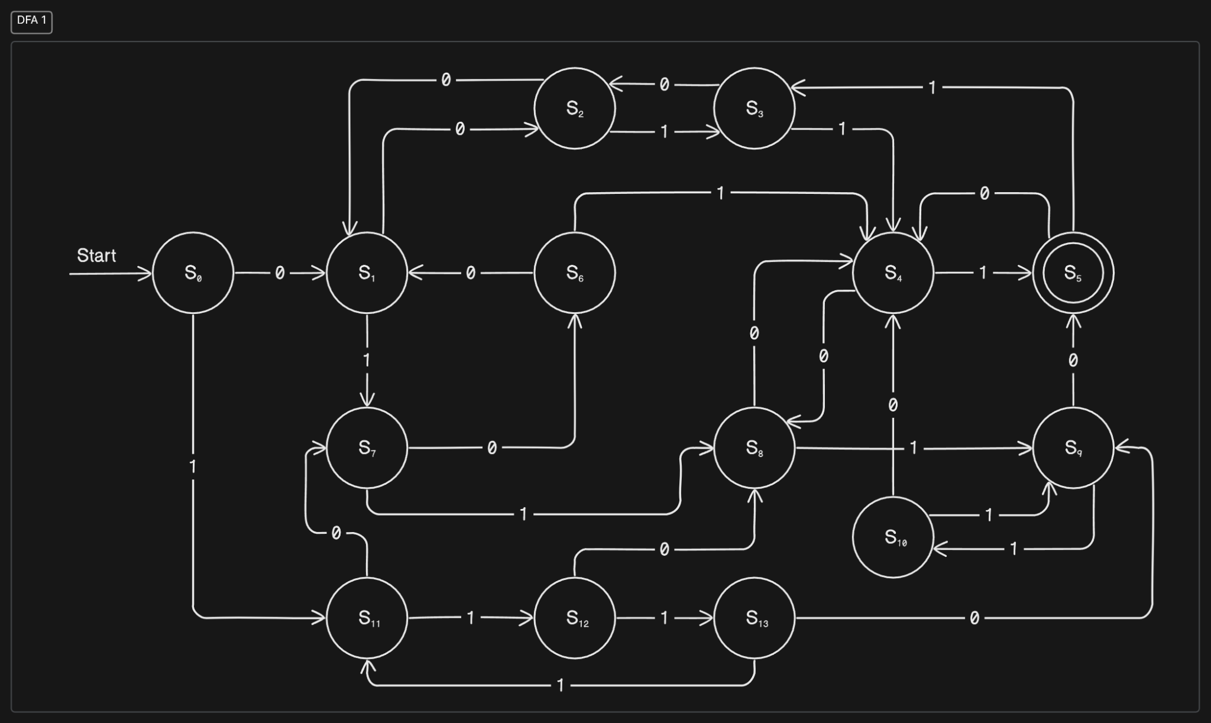



|  | 0 | 1 |
| --- | --- | --- |
| S0 | S1 | S11 |
| S1 | S2 | S7 |
| S2 | S1 | S3 |
| S3 | S2 | S4 |
| S4 | S8 | S5 |
| S5 * | S4 | S4 |
| S6 | S1 | S4 |
| S7 | S6 | S8 |
| S8 | S4 | S9 |
| S9 | S5 | S10 |
| S10 | S4 | S9 |
| S11 | S7 | S12 |
| S12 | S8 | S13 |
| S13 | S9 | S11 |

Tabel Transisi Percobaan

| String | Status |
| --- | --- |
| 00111 | Diterima |
| 11100 | Diterima |
| 11010 | Diterima |
| 01110 | Diterima |
| 01011 | Diterima |
| 10101 | Diterima |
| 01010 | Ditolak |
| 11111 | Ditolak |
| 00000 | Ditolak |

1. 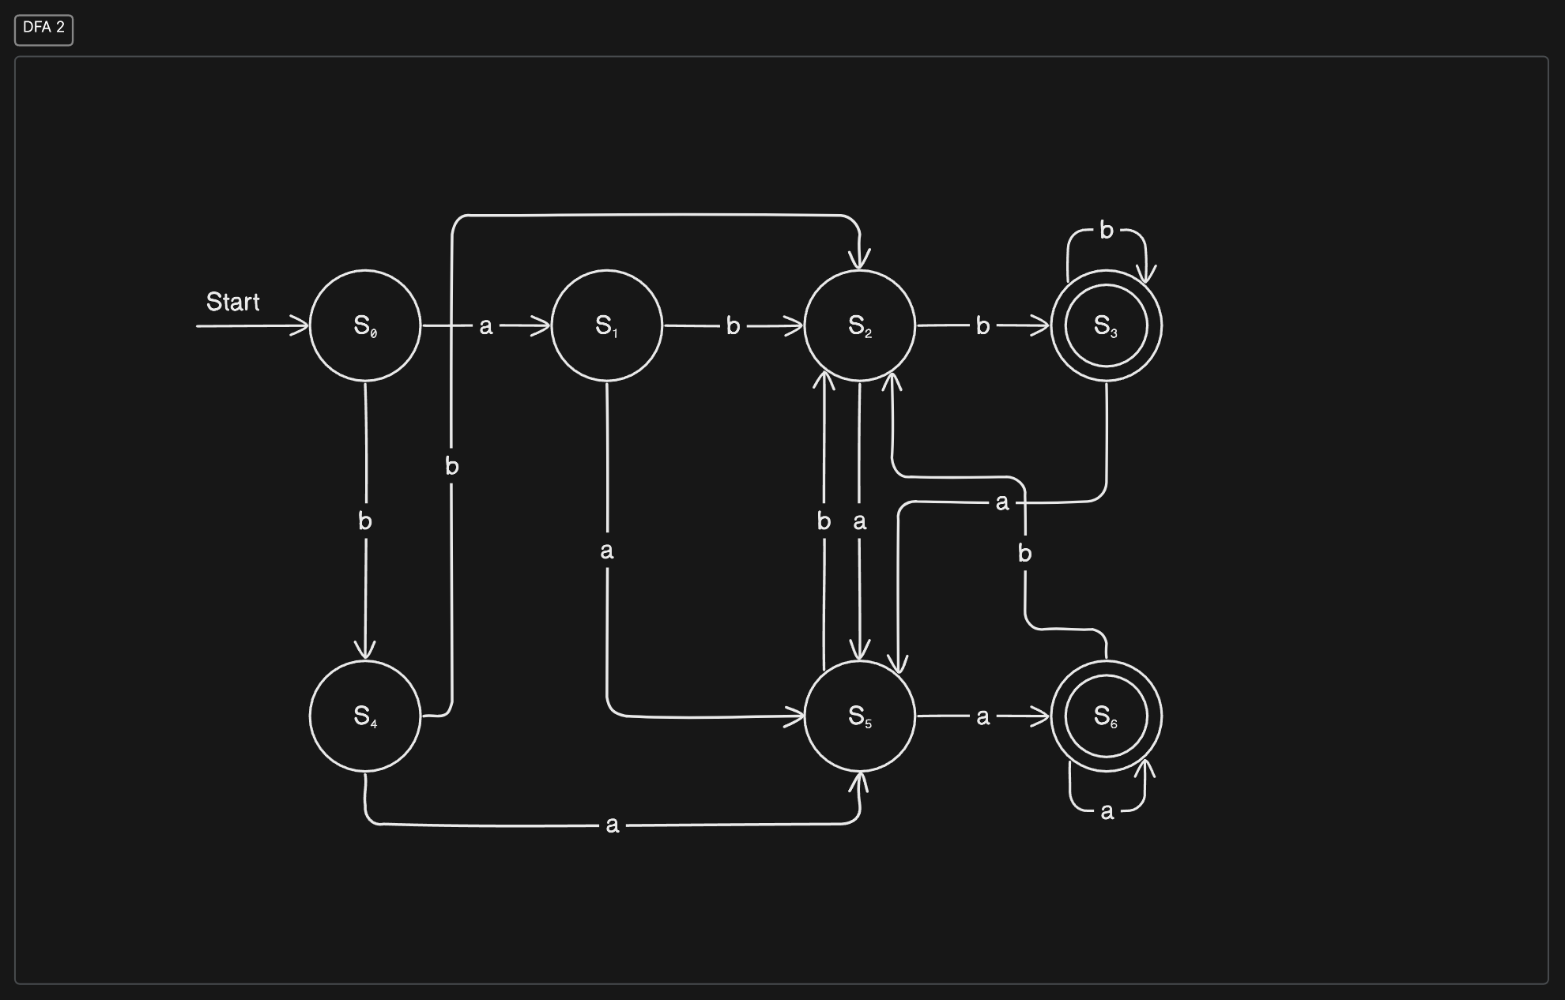

Tabel Transisi Percobaan

|  | a | b |  | String | Status |
| --- | --- | --- | --- | --- | --- |
| S0 | S1 | S4 |  | aaa | Diterima |
| S1 | S5 | S2 |  | baa | Diterima |
| S2 | S5 | S3 |  | aabb | Diterima |
| S3 * | S5 | S3 |  | babababab | Ditolak |
| S4 | S5 | S2 |  | abbbababb | Diterima |
| S5 | S6 | S2 |  | aaaabbbbbaa | Diterima |
| S6 * | S6 | S2 |  | abbaabba | Ditolak |